YONEX North Harbour International 2019
Auckland, New Zealand
21-24 March
PRACTICE REQUEST FORM

MEMBER ASSOCIATION Country: |  | CONTACT NAME in full:
CONTACT phone number: |  | CONTACT email address:

DATE | NUMBER OF PLAYERS | START TIME | FINISH TIME
19 March 09:00-19:00
20 March
09:00-19:00

Notes:
- There are six (6) main competition courts and four (4) warm up and practice courts.
- Based on information provided above by all participants, the event organiser will arrange fair practice session times on the main competition and practice courts as requested.
Please return this form by 11 March 2019 to:
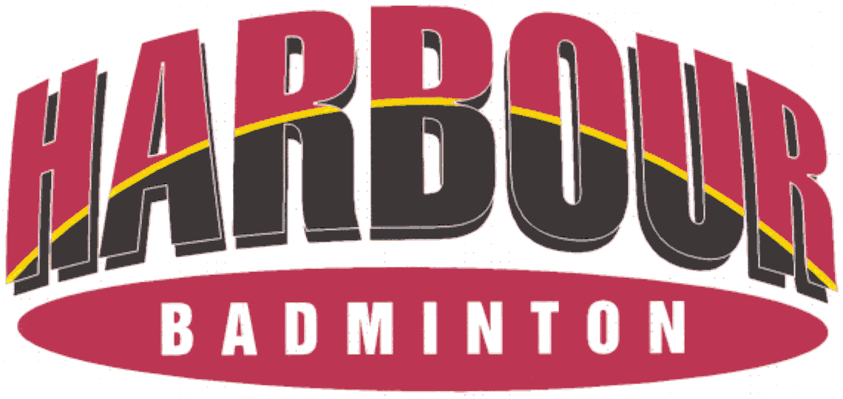
Event Director
Email: lisa@bnh.org.nz Telephone: +64 21477 794

