YONEX North Harbour International 2019
Auckland, New Zealand
21-24 March
VISA REQUEST FORM
MEMBER ASSOCIATION Country: |  | CONTACT NAME in full:
CONTACT phone number: |  | CONTACT email address:

NO | FAMILY NAME (on passport) | GIVEN NAMES (on passport) | GENDER | NATIONALITY | PASSPORT NUMBER | EXPIRY DATE | DATE OF BIRTH | ROLE (player, coach, etc)
1
2
3
4
5
6
7
8
9
10
Notes:
- Member associations requiring a Visa to enter New Zealand please complete the above form and return to Badminton North Harbour email: lisa@bnh.org.nz
- We will forward the official invitation letter for your visa application to your contact email address the next business day after receipt.
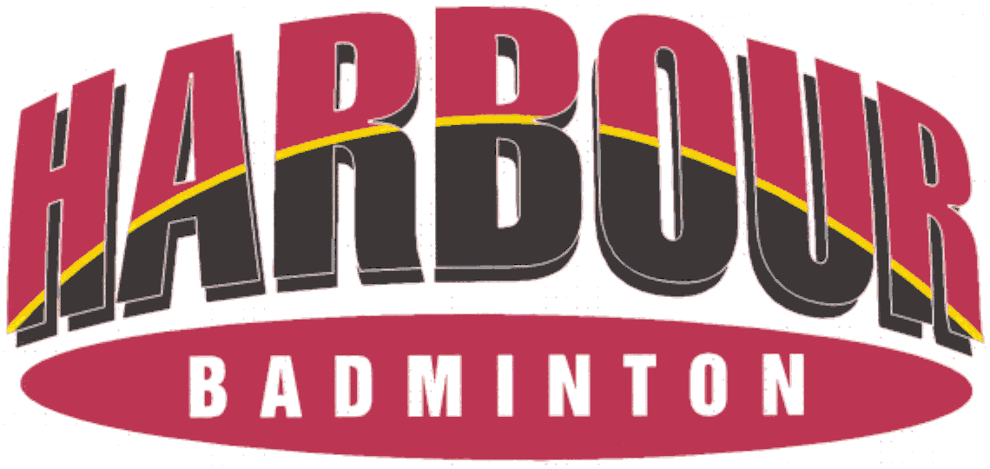
- Please allow sufficient time for you visa application. We recommend applying at least 30 days prior to your planned travel dates.

