YONEX North Harbour International 2020
Auckland, New Zealand
19-22 March
PRACTICE REQUEST FORM

MEMBER ASSOCIATION Country: |  | CONTACT NAME in full:
CONTACT phone number: |  | CONTACT email address:

DATE | NUMBER OF PLAYERS | START TIME | FINISH TIME
17 March 09:00-19:00
18 March
09:00-19:00

Notes:
- There are five (5) main competition courts and five (5) warm up and practice courts.
- Based on information provided above by all participants, the event organiser will arrange fair practice session times on the main competition and practice courts as requested.
Please return this form by 6 March 2020 to:
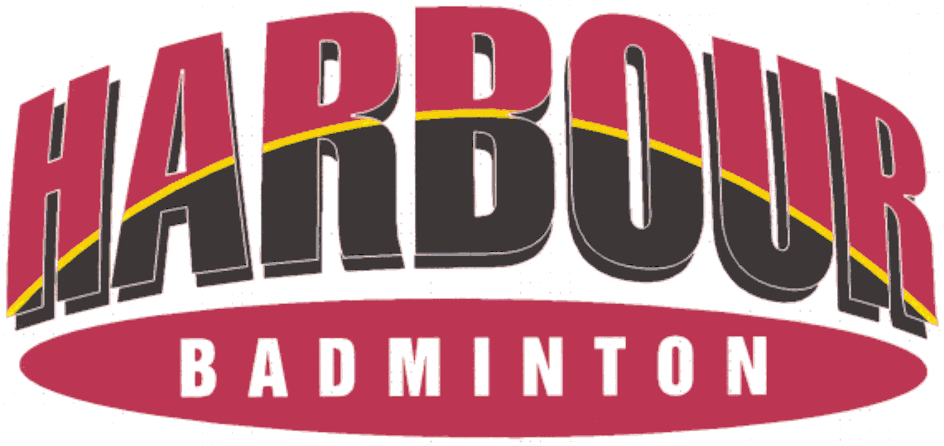
Event Director
Email: lisa@bnh.org.nz Telephone: +64 21477 794

