VICTOR North Harbour International 2022
Auckland, New Zealand
20-23 October
PRACTICE REQUEST FORM

MEMBER ASSOCIATION Country: |  | CONTACT NAME in full:
CONTACT phone number: |  | CONTACT email address:

DATE | NUMBER OF PLAYERS | START TIME | FINISH TIME
18 October
09:00-19:00
19 October 09:00-14:00
Notes:
- There are five (5) main competition courts and five (5) warm up and practice courts.
- Based on information provided above by all participants, the event organiser will arrange fair practice session times on the main competition and practice courts as requested.
Please return this form by 5 October 2022 to:
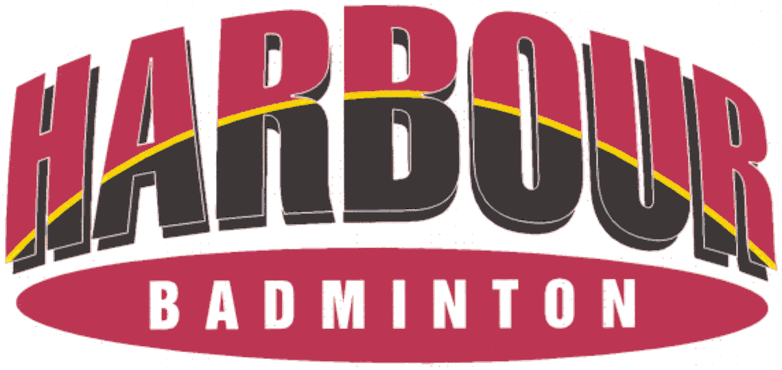
Event Director
Email: lisa@bnh.org.nz Telephone: +64 21477 794

